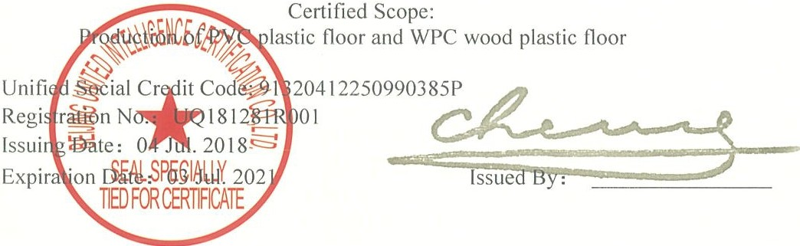

Management System Certification

QUALITY MANAGEMENT SYSTEM CERTIFICATION CERTIFICATE
TRAFFIX FLOORING INC.

Registered Address, 241 Bradwick Drive, Concord, Ont L4K 1K5

The Quality Management System Conforms to the Standard
ISO9001:2015

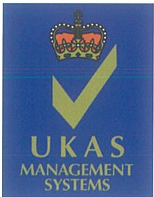
0277
The certified oganization should accept regular surveillance, if the surveillance are qualified, the certificate will sustain effective Address17/F,Building(TriumphCentre)170BeiyuanRoad,ChaoyangDist,BeijingPRChinaPostcode,l00101Tel:01084850008WebSite:www.uicec.com
ThiscertificationformatcanbequeriedontheCNCAofficialwebsite(www.cnca.gov.en)

Management System Certification

ENVIRONMENTAL MANAGEMENT SYSTEM CERTIFICATION CERTIFICATE

TRAFFIX FLOORING INC.
241 Bradwick Drive, Concord, Ontario L4K 1K5

The Environmental Management System Conforms to the Standard GB/T24001-2016/ISO14001:2015

Certified Scope:
Production of PVC plastic floor and WPC wood plastic floor and related management activities

91320412250990385P

04318E31153ROMO1

-
==
.....
y.

04 Jul.2020

03 Jul.2024

CNAS

MANAGEMENT SYSTEM CNASC043-M

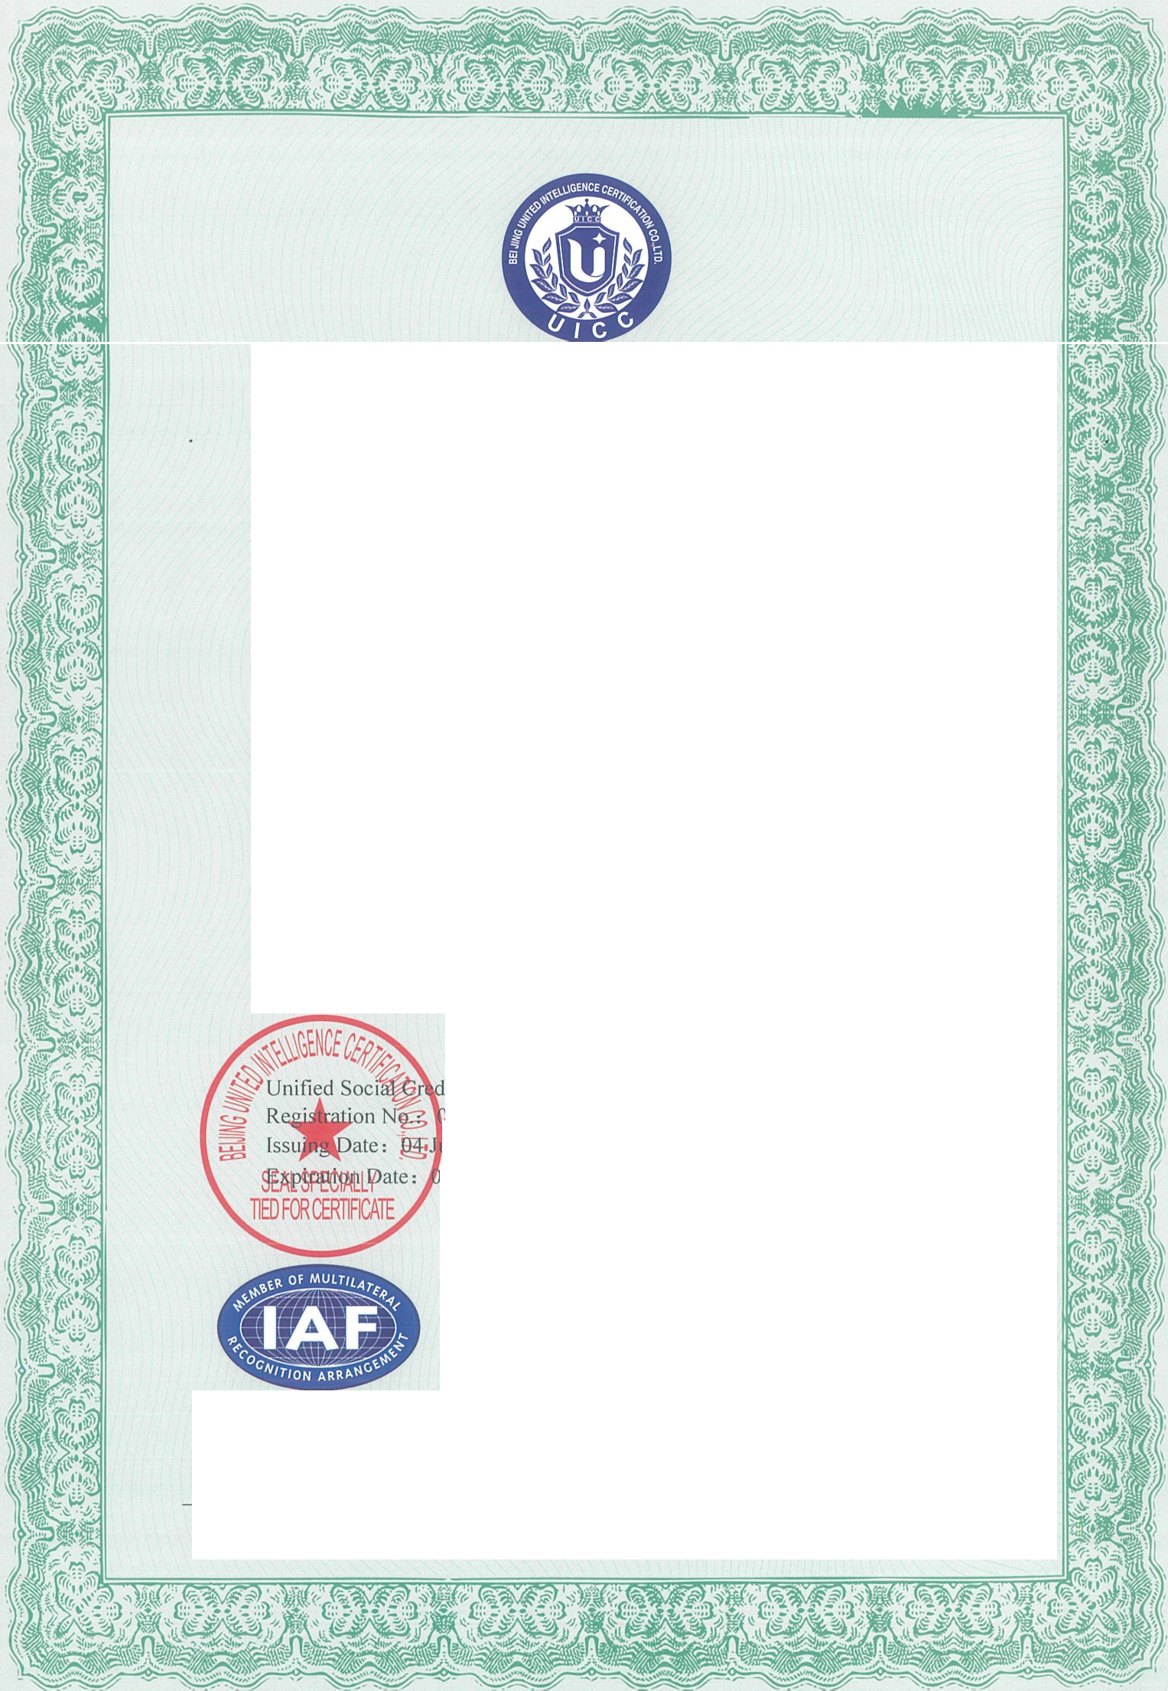

The certified organization should accept regular surveillance, If the surveillance are qualified, the certificate will sustain effective
Address, 17 Building (Triump Centre),l70BeiyuanRoad,ChaoyangDist.Beijing,P.R.ChinaPostcode:10010Tel 010-84850008Website: www:uicec.com
ThiscertificationinformaitoncanbequiredontheCNCAofficialwebsite(www.cnca.gov.en)

